CREATE TABLE EventPlan

(

PlanNo VARCHAR2(8) CONSTRAINT PlanNoNotNull NOT NULL,

EventNo VARCHAR2(8) CONSTRAINT EventNo1NotNull NOT NULL,

WorkDate DATE CONSTRAINT WorkDateNotNull NOT NULL,

Notes VARCHAR2(30),

Activity VARCHAR2(20) CONSTRAINT ActivityNotNull NOT NULL,

EmpNo VARCHAR2(8),

CONSTRAINT PK_EventPlan PRIMARY KEY (PlanNo),

CONSTRAINT FK_EventN0 FOREIGN KEY (EventNo) REFERENCES EventRequest (EventNo),

CONSTRAINT FK_EmpN0 FOREIGN KEY (EmpNo) REFERENCES EMPLOYEE (EmpNo),

CONSTRAINT CHECK_NOTES CHECK (Notes IN ('Standard operation','Watch for gate crashers','Watch for seat switching', 'Standard cleanup', 'Light cleanup', 'Extra security')),

CONSTRAINT CHECK_Activity CHECK (Activity IN ('operation', 'cleanup', 'setup'))

) ;

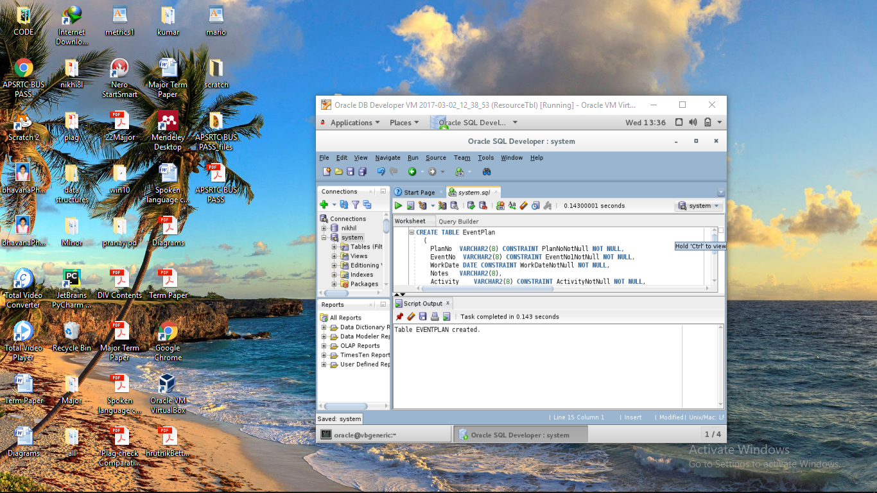

Select * from eventplan;

